**Dynamic Model Results**

$results

name beta_hat SD t p

1 Vehicles 0.02765030 0.01134959 2.4362371 1.484095e-02

2 Workers -0.05792614 0.00965009 -6.0026521 1.941203e-09

3 VehPrice.1 -0.34891613 0.06000013 -5.8152562 6.054108e-09

4 GasPrice.1 -0.36540375 0.04424345 -8.2589346 1.469785e-16

5 ASC -0.77269536 0.23993518 -3.2204338 1.279967e-03

6 VehPrice.2 -0.53964388 0.07618650 -7.0831954 1.408678e-12

7 ASC -2.17113042 0.96082106 -2.2596616 2.384226e-02

8 VehPrice.3 -0.50498705 0.19383936 -2.6051832 9.182515e-03

9 range.3 0.69666067 0.40025720 1.7405325 8.176556e-02

10 ElePrice.3 -0.10407608 0.17059971 -0.6100601 5.418220e-01

$maxLL

[1] -2745.97

attr(,"class")

[1] "dcModel"

Software: R studio (Version 1.0.136)

Running time: Around 90 seconds

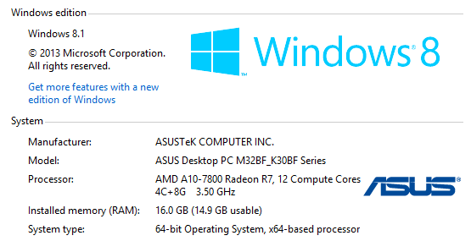

**Logit Model Results**

$results

name beta_hat SD t p

1 Vehicles 0.10601482 0.04664516 2.2727933 2.303864e-02

2 Workers -0.09182335 0.04012228 -2.2885874 2.210334e-02

3 VehPrice.1 -0.42263552 0.06223538 -6.7909204 1.114204e-11

4 GasPrice.1 -0.40939345 0.04504250 -9.0890477 9.991024e-20

5 ASC -1.26424654 0.24341958 -5.1936928 2.061632e-07

6 VehPrice.2 -0.49468212 0.07709670 -6.4163850 1.395483e-10

7 ASC -3.44376185 0.94069757 -3.6608597 2.513704e-04

8 VehPrice.3 -0.46808453 0.18659990 -2.5084929 1.212474e-02

9 range.3 1.14554920 0.39897186 2.8712531 4.088480e-03

10 ElePrice.3 -0.01989090 0.16636029 -0.1195652 9.048276e-01

$maxLL

[1] -3602.521

attr(,"class")

[1] "dcModel"

Software: R studio (Version 1.0.136)

Running time: Around 1 second